CSA15 – Cloud Computing and Big Data Analytics
Property Buying and Rental Management System for Chennai
using Zoho Creator (SaaS) with Big Data Analytics
SIMATS ENGINEERING
Department of Computer Science and Engineering

COMMON ASSIGNMENT REPORT
Submitted by | Student Register Number
B PRAVEEN KUMAR | 192511135
Assignment scope: cloud/SaaS application design, Zoho Creator implementation, Chennai property buying and rental workflow, property/tenant/owner data management, sample transaction dataset, and MapReduce-based property-demand analytics.

CERTIFICATE AND DECLARATION
This report is submitted as the common assignment work for CSA15 – Cloud Computing and Big Data Analytics. The assignment applies cloud computing and big-data concepts to a practical Property Buying and Rental Management System for Chennai.
Team Member | Register Number | Role in the Assignment
B. PRAVEEN KUMAR | 192511135 | Zoho Creator implementation, reports, analytics integration, documentation

Declaration
We declare that this report represents our assignment work and that external sources, tools and course-provided material have been acknowledged. The report distinguishes the proposed property-management workflow from sample analytics data prepared for MapReduce experimentation.
Student Signature | Date
B PRAVEEN KUMAR | 192511135
Source basis: the supplied Library Book Reservation report is used as the structural template, while the supplied Property Buying and Rental Process document provides the replacement domain/title.

ACKNOWLEDGEMENT
We express our sincere gratitude to the Department of Computer Science and Engineering, SIMATS Engineering, for providing the common-assignment framework through which cloud computing and big-data concepts could be applied to a realistic property-management scenario.
We thank our course faculty for guidance on Software as a Service, cloud access, virtualization concepts, big-data characteristics and MapReduce processing. The assignment encouraged us to convert a real-world property buying and rental process into structured cloud forms, workflows, reports and analytics.
We acknowledge Zoho Creator as the SaaS platform selected to construct the cloud-based application interface, data-entry forms, reports, workflows and dashboards.
The project helped us understand how property listings, owners, buyers, tenants, enquiries, site visits, purchases and rental agreements can be maintained in one centralized cloud application and later analysed as transaction data.

Key learning areas
- Mapping a Chennai property buying and rental process into structured cloud forms and reports.
- Understanding how SaaS reduces the need for local infrastructure management.
- Designing validations and status transitions for property availability, enquiries, sales and rentals.
- Preparing a transaction dataset suitable for demand and locality analysis.
- Using mapper/reducer logic to aggregate property enquiries or rental demand by locality/property type.

ABSTRACT
The Property Buying and Rental Management System for Chennai is a cloud-based Software as a Service application designed using Zoho Creator. The system addresses the need for a centralized platform to maintain property listings, owner and customer details, buying enquiries, rental requests, site visits, booking status and transaction records.
The system supports property owners or administrators in adding and updating property details, while buyers and tenants can search properties, check availability, submit enquiries, request site visits and track the status of their buying or rental process. The application is designed around structured forms, validation rules, workflows, reports and dashboards.
For the big-data component, a sample Chennai property-transaction dataset is prepared containing property ID, locality, property type, transaction type, customer ID, transaction date, price/rent and status. The dataset is used to illustrate volume, velocity, variety, veracity, privacy and scalability concerns. A MapReduce-style mapper can emit (Locality, 1) for each valid enquiry/booking and the reducer can calculate demand frequency by locality.
Component | Purpose
Zoho Creator SaaS | Cloud application, forms, records, workflows, reports and access
Property workflow | Search, enquiry, site visit, purchase/rental processing and status lifecycle
Analytics dataset | Sample Chennai property transaction data for demand analysis
MapReduce | Aggregate property demand by locality/type

TABLE OF CONTENTS AND REPORT STRUCTURE
Section | Page
Title, certificate, acknowledgement and abstract | 1–4
Introduction, problem statement and objectives | 6–8
Requirements and cloud service model | 9–10
Cloud infrastructure and system design | 11–13
Fields and implementation procedure | 14–15
Implementation evidence | 16–17
Forms, validation and workflows | 18–20
Reports and dashboard | 21
Big-data analysis and dataset | 22–23
MapReduce design and source | 24–25
Testing and validation | 26
Results, advantages, limitations and conclusion | 27–28
CO mapping and individual reflections | 29–30
The structure follows the supplied Library Book Reservation report, with the library domain replaced by the Property Buying and Rental Process domain.
Assessment alignment: SaaS service model, virtualization/cloud infrastructure, Zoho Creator forms and validation, cloud workflows and collaboration, big-data analysis, MapReduce analytics, testing, screenshots, reflection and presentation.

1. INTRODUCTION
Chennai has a wide range of residential and commercial properties available for purchase and rent. Managing property listings, owners, customers, prices, availability, enquiries, site visits and transactions through disconnected records can make the process time-consuming and difficult to monitor.
A cloud-based property management application provides a centralized workspace where authorized users can access the same property information. Owners or administrators maintain authoritative property records, while buyers and tenants can discover available properties and submit requests.
Zoho Creator is selected because the assignment requires a cloud-based SaaS implementation using forms, validations, workflows, role-based access, reports, dashboards and notifications. The platform allows the team to configure an application through a web interface without managing the complete underlying server infrastructure.
The project also connects operational property data with big-data analytics. As listings, enquiries, visits, bookings, sales and rental agreements accumulate, analytics can reveal high-demand localities, popular property types, price/rent patterns and customer activity.
Scope: The assignment focuses on property buying and rental management for Chennai and a simple demand-frequency analytics pipeline. Advanced banking/payment gateway integration, legal verification services and production-scale distributed storage are outside the demonstrated academic scope.

2. PROBLEM STATEMENT AND PROBLEM FORMULATION
The assignment requires a Property Buying and Rental Management System using Zoho Creator as a cloud-based SaaS application with Big Data Analytics. The application should support property listing, searching, availability checking, buying/rental enquiries, site-visit requests, booking and transaction-status tracking. Administrators should manage property information, customer records, owners, agreements and reports.
The problem can be formulated as a sequence of related information operations. A customer begins with a property search. The system returns matching properties and availability. The customer submits a buying or rental enquiry and may request a site visit. The request is validated and its status progresses through enquiry, visit, booking, agreement and completed/cancelled states.
Inputs | Outputs
Property ID, type, locality, address and area | Property search and availability reports
Owner/agent details | Enquiry and site-visit status
Buyer/tenant information | Booking and transaction records
Sale price / monthly rent / deposit | Rental and purchase summaries
Dates and operational status | Locality/property-type demand analytics
Agreement and transaction details | Management dashboard and reports

3. OBJECTIVES AND EXPECTED OUTCOMES
- Create a structured property-management application in Zoho Creator using forms, reports and workflows.
- Capture complete property, owner, buyer/tenant and transaction information.
- Allow users to search properties by Chennai locality, property type, budget and transaction type.
- Show whether a property is available for sale or rent.
- Represent enquiry, site visit, booking, purchase and rental decisions through status and workflow logic.
- Maintain rental agreement, rent, deposit and occupancy information.
- Provide reports for properties, enquiries, bookings, sales and rentals.
- Explain Zoho Creator as a SaaS solution and relate it to cloud access and collaboration.
- Prepare a clean sample property-transaction dataset for big-data discussion and analytics.
- Implement mapper/reducer logic that aggregates demand frequency by locality or property type.
Expected learning outcomes: By completing the assignment, the team should be able to distinguish SaaS from IaaS/PaaS, relate application hosting to virtualized cloud infrastructure, construct cloud forms and workflows, identify big-data challenges in a real domain, and apply MapReduce-style aggregation to property transaction data.

4. SYSTEM REQUIREMENTS
Requirement | Description | Priority
Registration / access | Identify customers, owners and administrators and control access. | High
Property management | Add, update and manage property listings and availability. | High
Search | Find properties by locality, type, budget and transaction type. | High
Availability | Show whether a property is available, reserved, sold or rented. | High
Buying enquiry | Create and track a purchase enquiry. | High
Rental enquiry | Create and track a rental request. | High
Site visit | Record requested and completed site visits. | Medium
Booking / agreement | Track booking, sale or rental agreement status. | High
Reports | Provide property and transaction summaries. | High
Analytics | Aggregate demand by locality/property type. | High
Non-functional requirements: Browser-based access, consistent field names, validation, role-based access, understandable reports, data privacy and repeatable analytics processing.
Constraints: The academic implementation uses sample records and a sample analytics dataset. Production payment processing, legal-document verification, identity management, enterprise backup and large-scale notification infrastructure are not evaluated here.

5. CLOUD SERVICE MODEL – SOFTWARE AS A SERVICE
Model | Customer primarily manages | Example role in this project
IaaS | VMs, operating systems, applications and data | Conceptual infrastructure layer
PaaS | Application logic and data while platform manages run | timeConceptual development layer
SaaS | Configuration and use of a ready cloud application | Zoho Creator property application
Zoho Creator is treated as the SaaS layer for this assignment because the team configures an application through a cloud service rather than installing and operating a complete application server stack. Forms, reports and application components are accessed through a browser.
- Browser-based access to property records and workflows.
- Centralized property data rather than separate local files.
- Reduced need for the student team to administer servers.
- Rapid configuration of forms, reports and workflows.
- Shared environment suitable for collaborative development and demonstration.

6. VIRTUALIZATION AND CLOUD INFRASTRUCTURE DESIGN
Virtualization allows physical computing resources to be abstracted into virtual resources such as compute, storage and networking. A SaaS provider can operate application services on cloud infrastructure where physical resources are shared and logically isolated for different workloads.
Conceptual architecture: Chennai customers, property owners and administrators access the Zoho Creator application through a web browser. The SaaS environment provides forms and workflows; structured property data feeds reports and dashboards; a separate analytics dataset can be exported or prepared for MapReduce processing.
Layer | Role
Users | Buyer, tenant, owner/agent, administrator
SaaS application | Zoho Creator forms, workflows and reports
Data | Property, customer, owner and transaction records
Reporting | Availability, enquiry, booking and transaction reports
Analytics | Prepared dataset + mapper + reducer

7. SYSTEM DESIGN / PROPOSED SOLUTION
The proposed system follows a layered design. The presentation/access layer is the Zoho Creator web interface. The application layer contains forms, validations and workflow rules. The data layer stores property, owner, customer and transaction information. The reporting layer provides operational views, while the analytics layer uses a prepared transaction dataset for demand aggregation.
Layer | Main components | Purpose
Access | Browser / user role | Reach cloud application
Application | Forms, validation, workflow | Capture and control operations
Data | Property, Owner, Customer, Enquiry, Booking, | Agreement Maintain structured records
Reporting | Reports and dashboard | Support monitoring and decisions
Analytics | Dataset + mapper + reducer | Measure property demand

Primary roles
- Buyer/Tenant: search properties, view availability, submit enquiries, request visits and track status.
- Owner/Agent: maintain property listings and respond to customer requests.
- Administrator: manage records, workflows, reports, access and transaction monitoring.

8. LOGICAL DATA MODEL
The central entities are Property, Owner, Customer and Enquiry/Transaction. A Property is associated with an owner or agent and can receive multiple enquiries. An enquiry can lead to a site visit, booking, sale transaction or rental agreement.
Entity | Important attributes
Property | Property ID, type, locality, address, area, bedrooms, furnishing, sale price, rent, deposit, status
Owner | Owner ID, name, contact, email, property references
Customer | Customer ID, name, contact, requirement, budget
Enquiry | Enquiry ID, customer, property, transaction type, date, status
Site Visit | Visit ID, enquiry, date/time, status, remarks
Booking | Booking ID, property, customer, date, amount, status
Rental Agreement | Agreement ID, property, tenant, rent, deposit, start/end date, status
Transaction | Transaction ID, property, customer, type, amount, date, status
Stable identifiers such as Property ID, Owner ID and Customer ID provide reliable references between records. Validation should prevent missing mandatory identifiers and maintain logical property availability and transaction states.

9. PROPERTY, CUSTOMER AND TRANSACTION FIELD SPECIFICATION
Entity | Field | Purpose / validation idea
Property | Property ID | Unique identifier; mandatory
Property | Property Type | Apartment, villa, house, plot, commercial, etc.
Property | Locality | Chennai locality; mandatory
Property | Area / Bedrooms | Numeric property characteristics
Property | Sale Price | Non-negative monetary value
Property | Monthly Rent | Non-negative monetary value
Property | Deposit | Non-negative monetary value
Property | Status | Available / Reserved / Sold / Rented
Owner | Owner ID / Name / Contact | Required ownership information
Customer | Customer ID / Name / Contact | Required buyer/tenant information
Enquiry | Enquiry ID / Property ID / Custo | mer IDLinks customer requirement to property
Enquiry | Transaction Type | Buy or Rent
Visit | Visit Date / Status | Track site visit
Agreement | Start / End Date | Rental lifecycle
Transaction | Amount / Date / Status | Purchase or rental transaction

10. ZOHO CREATOR IMPLEMENTATION PROCEDURE
- Create or access the Zoho Creator environment and create a new application for property buying and rentalmanagement.
- Create the Property form with property ID, locality, type, area, price/rent and availability fields.
- Create Owner and Customer forms for user-related information.
- Create Enquiry, Site Visit, Booking, Rental Agreement and Transaction forms.
- Configure required fields and validation rules.
- Create reports for available properties, enquiries, visits, bookings, sales and rentals.
- Configure workflows for enquiry status, availability changes, visit scheduling and transaction completion.
- Create a dashboard/navigation structure for the main modules.
- Enter sample Chennai property records and verify reports.
- Prepare a separate transaction dataset for MapReduce-based analytics.
Tool / environment | Use
Zoho Creator | SaaS application, forms, workflows, reports and cloud access
Web browser | Application access and testing
Python 3 | Sample dataset and MapReduce-style scripts
CSV | Portable transaction dataset
PDF/DOCX tools | Assignment documentation and evidence

IMPLEMENTATION EVIDENCE
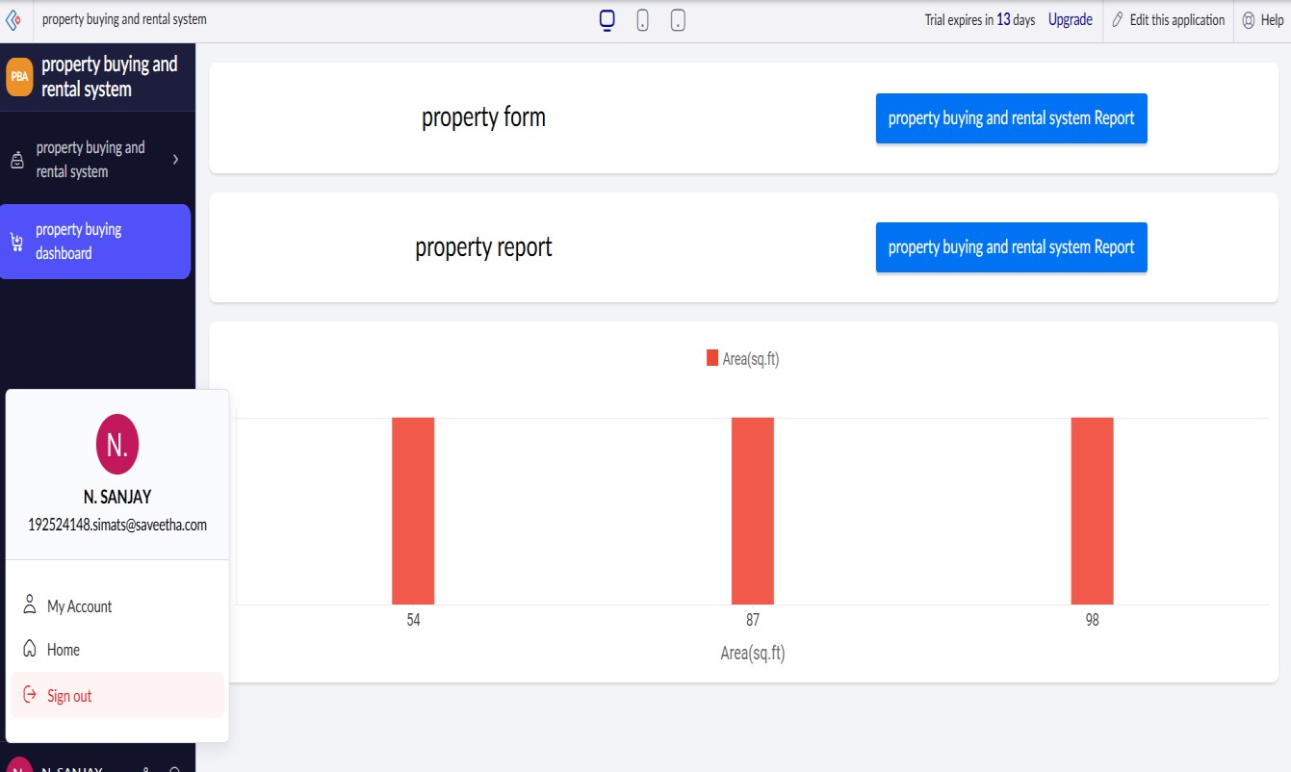

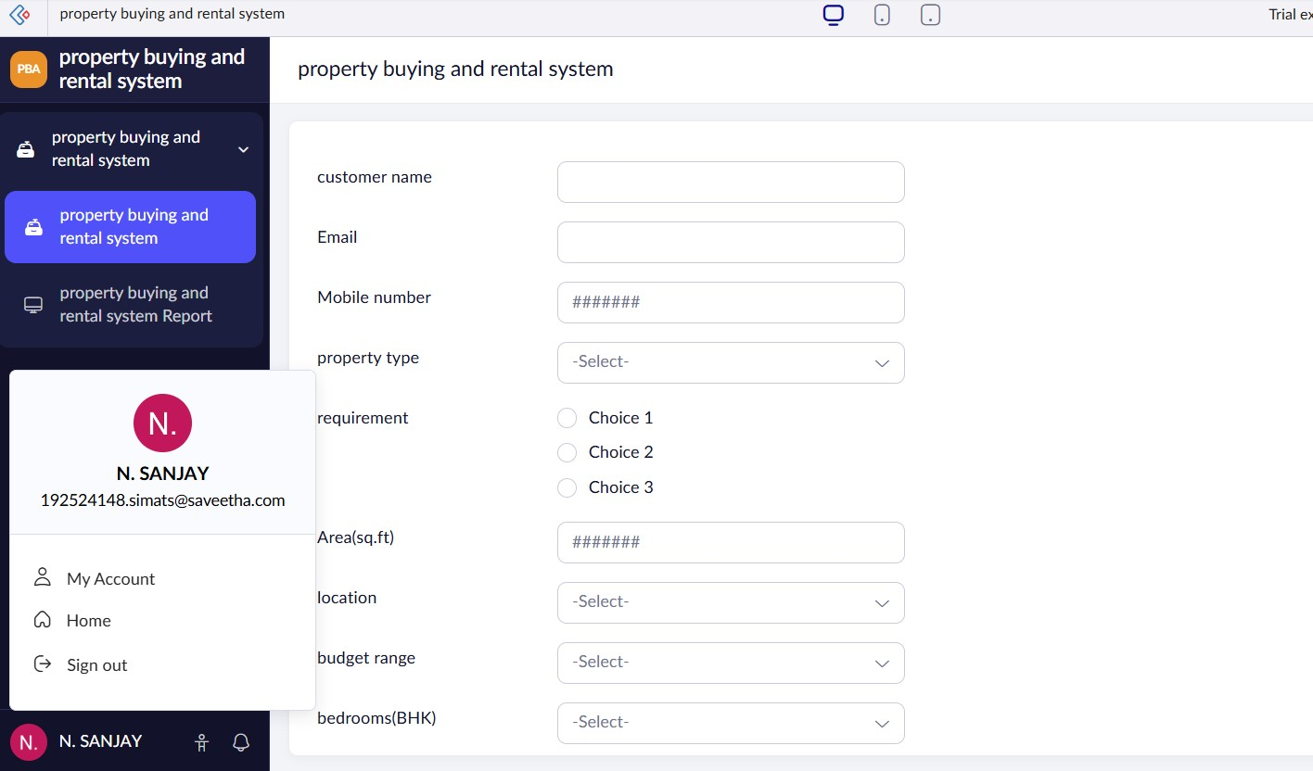
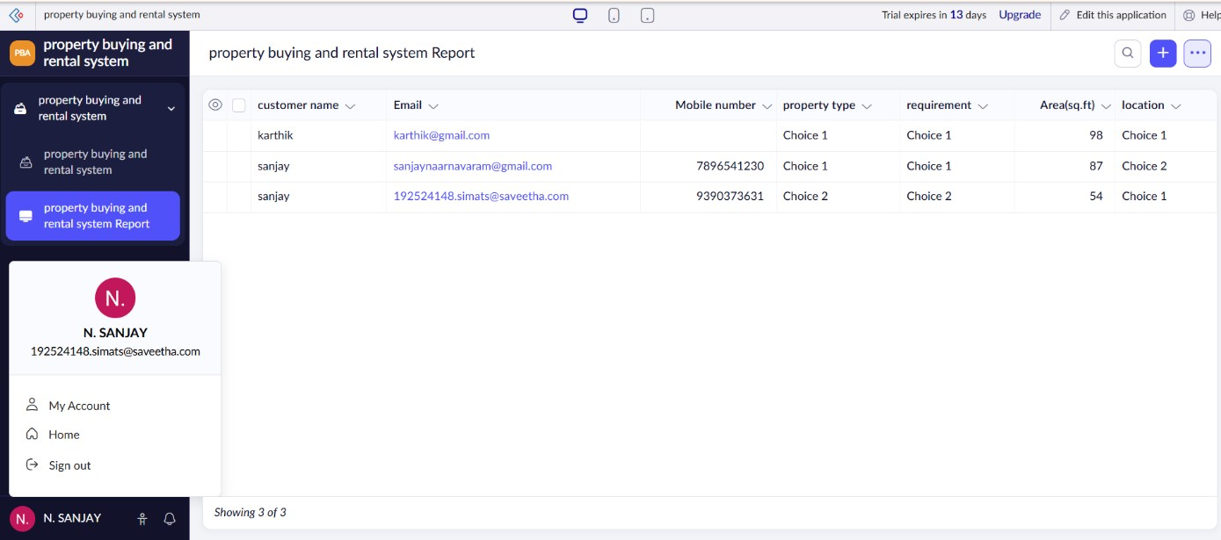

13. FORMS CREATED AND DATA ENTRY
Form | Main fields | Primary user
Property Form | Property ID, type, locality, address, area, bedrooms, price, ren | t, deposit, statusOwner/Admin
Owner Form | Owner ID, name, contact, email | Admin
Customer Form | Customer ID, name, contact, requirement, budget | Admin/Customer
Enquiry Form | Enquiry ID, customer, property, type, date, status | Buyer/Tenant/Admin
Site Visit | Visit ID, enquiry, date/time, status, remarks | Admin/Agent
Booking Form | Booking ID, property, customer, date, amount, status | Admin
Rental Agreement | Agreement ID, property, tenant, rent, deposit, dates, status | Admin
Transaction Form | Transaction ID, property, customer, type, amount, date, status | Admin

Data-entry principles
- Use stable IDs rather than relying only on names.
- Keep monetary and area values numeric and non-negative.
- Use controlled status choices.
- Keep dates logically ordered.
- Associate every enquiry with a valid customer and property.
- Preserve transaction history rather than overwriting completed records.

14. VALIDATION AND DATA QUALITY RULES
Rule | Example condition | Reason
Unique Property ID | No duplicate identifier | Prevents ambiguous property references
Required locality | Locality is not blank | Supports search and analytics
Price/rent bounds | Value ≥ 0 | Prevents invalid financial values
Property status | Allowed status set | Maintains lifecycle consistency
Customer reference | Customer ID exists | Prevents orphan enquiries
Property reference | Property ID exists | Links enquiry to listing
Agreement dates | End date ≥ start date | Prevents invalid rental period
Transaction amount | Amount ≥ 0 | Improves financial data quality
Contact format | Valid expected pattern | Improves customer data quality
Validation is important for analytics. Consistent Property ID and locality values ensure that the same property or area is not split into multiple analytical keys. Customer contact information should be protected through role-based access and data minimization.

15. PROPERTY BUYING AND RENTAL WORKFLOW AND AUTOMATION
The workflow begins with authenticated access and a property search. The customer selects a property and submits a buying or rental enquiry. The application validates the customer and property references and checks availability. The customer may request a site visit. After the visit, the property can move to booking, sale or rental agreement stages.
Stage | Typical status
Property listing | Available
Customer enquiry | New / Under Review
Site visit | Requested / Scheduled / Completed
Booking | Booked / Cancelled
Purchase | Sale Pending / Sold
Rental | Agreement Pending / Rented
End of rental | Active / Completed
Automation opportunities: notification when an enquiry is received, site-visit reminders, automatic status updates after booking, availability changes after sale/rental completion, rental expiry reminders and dashboard alerts for pending requests.

16. SEARCH, REPORTS AND DASHBOARD
Report / view | Purpose
Property Report | General property catalogue with location and price/rent details
Available Property | Show properties currently available
Locality Report | Compare listings and transactions across Chennai localities
Enquiry Report | Track buying/rental enquiries by status and date
Site Visit Report | Monitor scheduled and completed visits
Booking Report | Track property bookings
Rental Report | Track active and completed rental agreements
Transaction Report | Summarize purchase and rental transactions
Demand Report | Compare demand by locality/property type
Dashboard | Summarized operational and analytics view
Dashboard cards can show total properties, available properties, active enquiries, upcoming site visits, booked properties, sold properties and rented properties. Charts can show demand by locality and property type.

17. BIG DATA PROBLEM ANALYSIS
Big-data dimension | Property-management example | System implication
Volume | Large number of listings, enquiries, visits and t | ransactions over yearsEfficient storage and aggregation
Velocity | New enquiries, status changes and transactio | ns arrive continuouFrequent updates and monitoringly
Variety | Forms, CSV exports, reports, addresses and t | ransaction recordsSchema/format normalization
Veracity | Duplicate properties, missing prices, inconsist | ent locality namesValidation and cleaning
Privacy | Customer and owner contact information | Role-based access and minimization
Scalability | Growing Chennai property inventory and trans | action historyPartitionable analytics and cloud resources
A small classroom dataset does not itself represent industrial-scale big data. Its purpose is to model a continuously growing property transaction stream and demonstrate an analytical method that can conceptually scale to larger datasets.

18. SAMPLE CHENNAI PROPERTY-TRANSACTION DATASET
A sample dataset can be prepared with fields for Transaction_ID, Customer_ID, Property_ID, Locality, Property_Type, Transaction_Type, Transaction Date, Amount and Status. The dataset is synthetic and intended for demonstration rather than representing actual Chennai customers or transactions.
Field | Example | Analytics use
Transaction_ID | T001 | Unique transaction reference
Customer_ID | C101 | Optional customer grouping
Property_ID | P001 | Primary property key
Locality | Avadi | Locality-level demand analysis
Property_Type | Apartment | Property-type comparison
Transaction_Type | Rent | Buying/rental comparison
Transaction_Date | 2026-08-14 | Time-based analysis
Amount | 25000 | Price/rent analysis
Status | Completed | Filter valid events
Dataset preparation steps: define a consistent schema; generate or collect transaction rows; check required fields and date formats; remove duplicate transaction IDs; select the analytical event to count; feed Locality and a value of 1 into the mapper.

19. MAPREDUCE APPLICATION DESIGN
The MapReduce problem is a counting task. Each valid property enquiry, booking or transaction is converted into a key-value pair where the key can be Locality and the value is 1. The shuffle-and-sort stage groups identical localities, and the reducer sums the values for each key.
Mapper logic: Read each transaction and emit (Locality, 1). If 25 valid events belong to Avadi, the mapper produces 25 pairs with the same locality key.
Reducer logic: For each grouped locality, initialize a counter and add each value. The final result is (Locality, total demand). The same design can use Property_Type as the key to calculate demand by property type.
Input event | Mapper output | Reducer result
Avadi enquiry | (Avadi, 1) | Avadi → total enquiries
Porur booking | (Porur, 1) | Porur → total bookings
Avadi rental | (Avadi, 1) | Avadi → increased demand

20. MAPREDUCE SOURCE CODE AND ANALYTICS OUTPUT
A compact Python implementation can demonstrate the MapReduce key-value idea using a CSV dataset.

mapper.py
import sys, csv
reader = csv.DictReader(sys.stdin) for row in reader: print(f"{row['Locality']}\t1") reducer.py
import sys current_key = None total = 0 for line in sys.stdin:
key, value = line.strip().split("\t") value = int(value) if current_key == key:
total += value else:
if current_key is not None:
print(f"{current_key}\t{total}") current_key = key total = value if current_key is not None: print(f"{current_key}\t{total}")
The resulting analytics file can contain Locality and Demand_Frequency. The highest-frequency locality in the final result depends on the prepared dataset and should be reported only after running the dataset.

21. TEST CASES AND VALIDATION
TC | Scenario | Expected result
T01 | Open property dashboard | Navigation and summary controls visible
T02 | Open Property Form | Property fields available for entry
T03 | View Property Report | Property records displayed
T04 | Search by locality | Matching Chennai properties displayed
T05 | View Available Property | Only available properties shown
T06 | Submit buying enquiry | Enquiry created with valid status
T07 | Submit rental enquiry | Rental enquiry created
T08 | Request site visit | Visit request recorded
T09 | Book property | Property status changes according to workflow
T10 | Complete rental agreement | Rental record and availability updated
T11 | Mapper count | One key-value pair per selected event
T12 | Reducer count | Demand frequency aggregated by locality
Screenshots should be used as evidence for actual implemented screens. Workflow states not demonstrated by screenshots should be documented as testable requirements rather than claimed as completed evidence.

22. RESULTS AND DISCUSSION
The proposed Zoho Creator application provides a centralized property-management structure containing forms, reports, workflows and analytics. The main operational result is a single cloud-accessible environment for property listings, customer requests and transaction lifecycle tracking.
Result area | Observation
Cloud access | Application is accessed through a web interface in Zoho Creator.
Property records | Property ID, locality, type, area and price/rent can be maintained in structured forms.
Availability | Property status can distinguish available, reserved, sold and rented listings.
Workflow | Buying/rental enquiries can be connected to site visits and transaction states.
Analytics | A synthetic transaction dataset supports demand-frequency analysis.
MapReduce | Locality/property-type aggregation demonstrates distributed-style key-value processing.
The analytical insight is that transaction frequency can act as a demand indicator. In a larger dataset, the same pipeline could be extended to locality trends, monthly demand, property-type popularity, rental-vs-buying comparisons and price/rent analysis.

23. ADVANTAGES, LIMITATIONS, SDG RELEVANCE AND CONCLUSION

Advantages
- Cloud accessibility through a SaaS application.
- Centralized property, customer and transaction records.• Reduced manual consolidation of listings and enquiries.
- Clear separation between operational records and analytics processing.
- MapReduce aggregation can conceptually scale to larger transaction datasets.

Limitations
- Academic implementation uses sample records rather than production property data.
- Legal ownership verification and document validation are outside the demonstrated scope.
- Payment gateway and banking integration are not evaluated.
- The sample analytics dataset is synthetic and relatively small.
- Production deployment would require stronger authentication, backup, audit and privacy controls.

SDG relevance
The project can be related to SDG 9 (Industry, Innovation and Infrastructure) through the use of cloud-based digital infrastructure. It can also support SDG 11 (Sustainable Cities and Communities) by improving the organization and visibility of urban property information and supporting more efficient access to housing-related services.
Conclusion: The project demonstrates a practical SaaS-based property buying and rental management system for Chennai and connects its transaction data to a MapReduce demand-analysis task. It provides a foundation for richer workflows, dashboards and scalable analytics.

24. CO MAPPING AND INDIVIDUAL REFLECTION – B PRAVEEN KUMAR (192511135)
CO | Evidence in this assignment
CO1 | SaaS explanation, Zoho Creator forms, requirements and validation concepts.
CO2 | Virtualization/cloud infrastructure architecture and relation to SaaS hosting.
CO3 | Cloud access, reports, workflows, collaboration and application evidence.
CO4 | Volume, velocity, variety, veracity, privacy and scalability analysis; dataset preparation.
CO5 | Mapper/reducer design, source code and property-demand analytics concept.

Individual reflection – B PRAVEEN KUMAR
My main contribution to the assignment was working with the Zoho Creator application, implementation evidence, reports and analytics integration. I learned that a cloud property-management application requires more than forms: the data model, validation rules, reports and workflow states must work together so that a customer or administrator action produces a meaningful and traceable record.
A major learning point was understanding SaaS in practical terms. The application can be configured and accessed through the cloud platform rather than requiring the team to manage the complete server stack. I also learned how property transaction records can become an analytics dataset and how a locality key can be used for MapReduce demand counting.

25. REFERENCES

References
- P. Mell and T. Grance, The NIST Definition of Cloud Computing, NIST SP 800-145, 2011.
- Zoho Corporation, Zoho Creator Help and developer documentation.
- J. Dean and S. Ghemawat, “MapReduce: Simplified Data Processing on Large Clusters,” OSDI'04, 2004.
- Apache Software Foundation, Apache Hadoop MapReduce documentation.
- United Nations Sustainable Development Goals documentation.
- Department of Computer Science and Engineering, SIMATS Engineering, CSA15 common-assignment instructions.
- Supplied Property Buying and Rental Process document – domain/title reference.
Submission package suggestion: 30-page report PDF, Zoho Creator screenshot evidence PDF, sample property_transactions.csv, mapper.py, reducer.py and MapReduce result CSV.

